**AIM:** Make a list of any 6 libraries of Python with their functionality in brief. And, also write the steps required for installing any new library in a given environment.

**Solution :**

**Steps for installing any new library in python in given environment:**

1. For installing any new library in python we have to install pip.
2. The easiest way to install pip is through the use of a python program called get-pip.py which we can download from internet.
3. After downloading this file simply use your browser to save this page under its default name, which is get-pip.py.
4. To avoid misplacement of file save this file in your python directory, so you know where to find it.
5. Once you have saved this file, you need to run it, which can be done in two ways.
6. If you prefer using your python interpreter, just right-click on the file get-pip.py and choose “open with” and then choose whatever python interpreter you care to use.
7. If you prefer to install pip using the windows command line, navigate to whatever directory you’ve placed python and get-pip.py.
8. For this example, we’ll assume this directory is python2.7, so we’ll use the command C:\>cd python2.7. Once you are in this directory, run the command:

python get-pip.py to install pip

1. **TensorFlow**

TensorFlow works like a computational library for writing new algorithms that involve a large number of tensor operations, since neural networks can be easily expressed as computational graphs they can be implemented using TensorFlow as a series of operations on Tensors. Plus, tensors are N-dimensional matrices which represent your data.

TensorFlow is used daily but indirectly with applications like Google Voice Search or Google Photos. These applications are developed using this library.All the libraries created in TensorFlow are written in C and C++. However, it has a complicated front-end for Python. Your Python code will get compiled and then executed on TensorFlow distributed execution engine built using C and C++.The number of applications of TensorFlow is literally unlimited and that is the beauty of TensorFlow.  
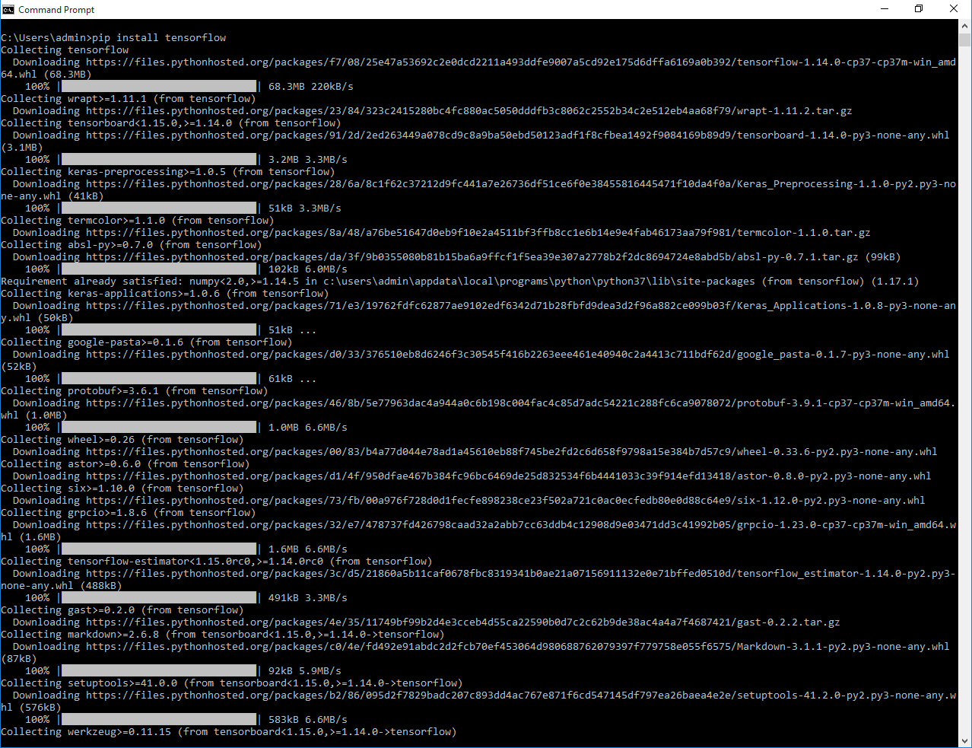

1. **Scikit-Learn**

It is a Python library is associated with NumPy and SciPy. It is considered as one of the best libraries for working with complex data.

It contains a numerous number of algorithms for implementing standard machine learning and data mining tasks like reducing dimensionality, classification, regression, clustering, and model selection.

1. **Numpy**

Numpy is considered as one of the most popular machine learning library in Python.TensorFlow and other libraries uses Numpy internally for performing multiple operations on Tensors. Array interface is the best and the most important feature of Numpy.

This interface can be utilized for expressing images, sound waves, and other binary raw streams as an array of real numbers in N-dimensional.For implementing this library for machine learning having knowledge of Numpy is important for full stack developers.

1. **Keras**

Keras is considered as one of the coolest machine learning libraries in Python. It provides an easier mechanism to express neural networks. Keras also provides some of the best utilities for compiling models, processing data-sets, visualization of graphs, and much more.In the backend, Keras uses either Theano or TensorFlow internally. Some of the most popular neural networks like CNTK can also be used. Keras is comparatively slow when we compare it with other machine learning libraries. Because it creates a computational graph by using back-end infrastructure and then makes use of it to perform operations. All the models in Keras are portable.

Keras contains numerous implementations of commonly used neural network building blocks such as layers, objectives, activation functions, optimizers and a host of tools to make working with image and text data easier. Plus, it provides many pre-processed data-sets and pre-trained models like MNIST, VGG, Inception, SqueezeNet, ResNet etc.

1. **SciPy**

SciPy is a machine learning library for application developers and engineers. However, you still need to know the difference between SciPy library and SciPy stack. SciPy library contains modules for optimization, linear algebra, integration, and statistics.

SciPy is a library that uses NumPy for the purpose of solving mathematical functions. SciPy uses NumPy arrays as the basic data structure, and comes with modules for various commonly used tasks in scientific programming.Tasks including linear algebra, integration (calculus), ordinary differential equation solving and signal processing are handled easily by SciPy.

1. **Pandas**

Pandas is a machine learning library in Python that provides data structures of high-level and a wide variety of tools for analysis. One of the great feature of this library is the ability to translate complex operations with data using one or two commands. Pandas have so many inbuilt methods for grouping, combining data, and filtering, as well as time-series functionality.

Currently, there are fewer releases of pandas library which includes hundred of new features, bug fixes, enhancements, and changes in API. The improvements in pandas regards its ability to group and sort data, select best suited output for the apply method, and provides support for performing custom types operations.

Data Analysis among everything else takes the highlight when it comes to usage of Pandas. But, Pandas when used with other libraries and tools ensure high functionality and good amount of flexibility.